Figures & Tables: Seaweed extracts strongly structured microbial communities associated with tomato and pepper roots and significantly increased crop yield

January 11, 2019

**Sébastien Renaut1,2 ,Jacynthe Masse1,2 , Jeffrey P. Norrie3 , Bachar Blal3 Mohamed Hijri1,2**

*1Département de Sciences Biologiques, Institut de Recherche en Biologie Végétale, Université de Montréal, 4101* *Sherbrooke Est, Montreal, H1X 2B2, Quebec, Canada.*  *2Quebec Centre for Biodiversity Science, Montreal, Quebec,*  *Canada*

*3Acadian Seaplant Ltd, 30 Brown Avenue, Darthmouth, Nova Scotia, Canada, B3B 1X8*

**Table 1: summary of PERMANOVAs**

|  |  |  |  |  |
| --- | --- | --- | --- | --- |
|  | fungi-soil | fungi-root | bacteria-soil | bacteria-root |
| fertilization | 0.02*** | 0.08*** | 0.04*** | 0.07*** |
| planted | 0.21*** | NA | 0.13*** | NA |
| species | 0.02*** | 0.26*** | 0.02*** | 0.52*** |
| fertilization:planted | 0.01** | NA | 0.02*** | NA |
| fertilization:species | 0.01* | 0.04* | 0.03*** | 0.05*** |
| planted:species | 0.01 | NA | 0.01** | NA |
| fertilization:planted:species | 0.01 | NA | 0.01* | NA |

$r^{2}$ (percentage of variance explained by the term in the model); *\*p-value<0.05, **<0.005, ***<0.0005*

Figure 1  
**Figure 1: Measures of plant productivity. *a* and *b* subscripts above boxplots denote significant differences according to the fertilization treatment. Fold changes between the mean of the control and fertilized plants were also noted for significant changes (for pepper and tomato separately).**  
   
   
   
Figure 2  
**Figure 2: Barplots of the relative abundance of fungal ASVs for fungi**

Figure 3  
**Figure 3: Barplots of the relative abundance of bacterial ASVs for bacteria**

Figure 4  
**Figure 4: Boxplot of $a$-diversity according to the treatment, species and planting effect for fungal-root, fungal-soil, bacteria-soil and bacteria-root. *a* and *b* subscripts above boxplots denote significant differences.**

Figure 5  
**Figure 5: Canonical correspondence analyses for soil-fungi and root-fungi. Samples were labeled and colored in gray (unfertilized) or dark yellow (fertilized). Red crosses represent individual ASVs, while red points represent the ten ASVs most closely associated with the three productivity measures of root fresh weight, shoots fresh weight and fruit number. Blue arrows are the four productivity measures used as constraints in the ordinations.**  

Figure 6  
**Figure 6: Canonical correspondence analyses for soil-bacteria and root-bacteria. Samples were labeled and colored in gray (unfertilized) or dark yellow (fertilized). Red crosses represent individual ASVs, while red points represent the ten ASVs most closely associated with the three productivity measures of root fresh weight, shoots fresh weight and fruit number. Blue arrows are the four productivity measures used as constraints in the ordinations.**

**Table S1: Soil characteristics (in ppm unless specified otherwise)**

|  |  |
| --- | --- |
| Soil Characteristics | Average value |
| pH | 6.01 |
| Conductivity (mmhos/cm) | 0.68 |
| Nitrate (N) | 62.40 |
| Ammonium | 0.09 |
| Phosphorus | 0.41 |
| Potassium | 29.30 |
| Calcium | 64.40 |
| Magnesium | 13.80 |
| Chloride | 28.50 |
| Sulfate | 19.30 |
| Sodium | 17.80 |
| Zinc | 0.12 |
| Manganese | 0.06 |
| Cooper | 0.81 |
| Iron | 0.90 |
| Aluminium | 1.66 |

 

**Table S2: Randomized Split Block Experimental design**  
 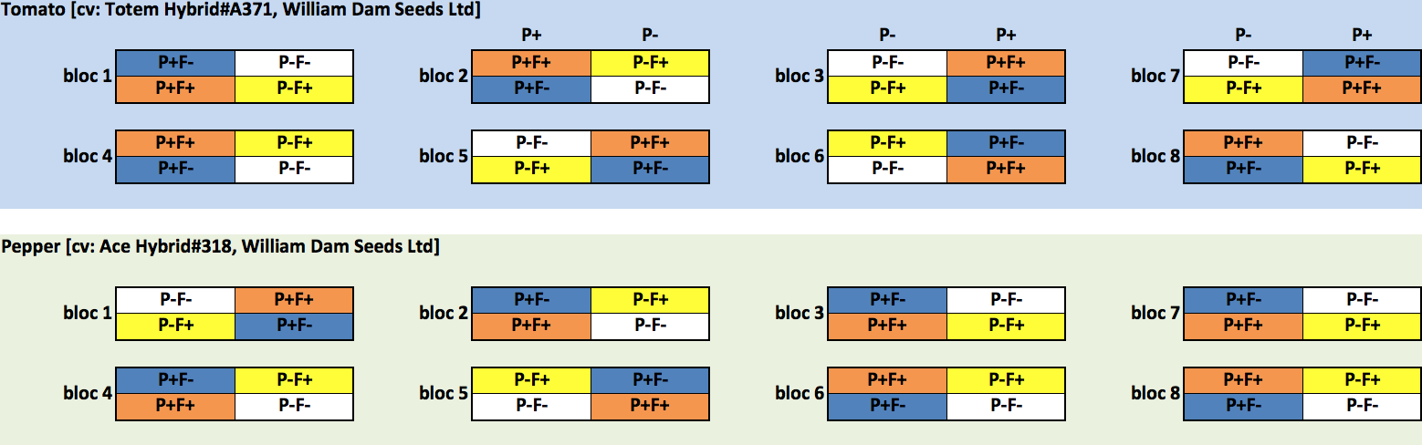

   
 

**TableS3: Stella Maris® characteristics**

|  |  |
| --- | --- |
| Stella Maris® characteristics | Average value |
| Appearance | Viscous Brownish-Black Liquid |
| Odor | Marine Odor |
| Solubility in water (%) | 100 |
| pH | 7.4 - 8.2 |
| Carbohydrates | Alginic acid, Mannitol, Fucoidans |
| Organic matter content (%) | 13.0 - 16.0 |
| Total Nitrogen (N) (%) | 0.1 - 0.6 |
| Available phosphate (P2O5) (%) | < 0.2 |
| Soluble potash (K2O) (%) | 5.0 - 7.0 |
| Sulphur (S) (%) | 0.3 - 0.6 |
| Magnesium (Mg) (%) | 0.05 - 0.15 |
| Calcium (Ca) (%) | 0.05 - 0.15 |
| Sodium (Na) (%) | 0.7 - 1.2 |
| Iron (Fe) (ppm) | 30 - 90 |
| Cooper (Cu) (ppm) | < 4 |
| Manganese (Mn) (ppm) | 3 - 11 |
| Boron (B) (ppm) | 20 - 40 |

   
 

**Table S4: Summary of sequencing and bioinformatics identification of ASVs**

|  |  |  |  |  |
| --- | --- | --- | --- | --- |
|  | fungi-soil | fungi-root | bacteria-soil | bacteria-root |
| No sequences (sum) | 976,000 | 309,000 | 920,000 | 535,000 |
| No sequences (mean) | 50,847 | 32,208 | 47,907 | 56,365 |
| No seq. filtered (mean) | 32,626 | 12,714 | 29,662 | 37,642 |
| No seq. filt. merged (mean) | 29,300 | 12,094 | 14,060 | 30,706 |
| No seq. filt. merg. no chimeras (mean) | 25,476 | 9,849 | 13,521 | 30,408 |
| No samples | 192 | 96 | 192 | 96 |
| No samples trimmed | 189 | 81 | 192 | 95 |
| No ASVs (sum) | 6,112 | 845 | 9,352 | 2,023 |
| No ASVs trimmed (sum) | 413 | 106 | 811 | 325 |
| ASV per sample (mean) | 176 | 37 | 269 | 92 |

  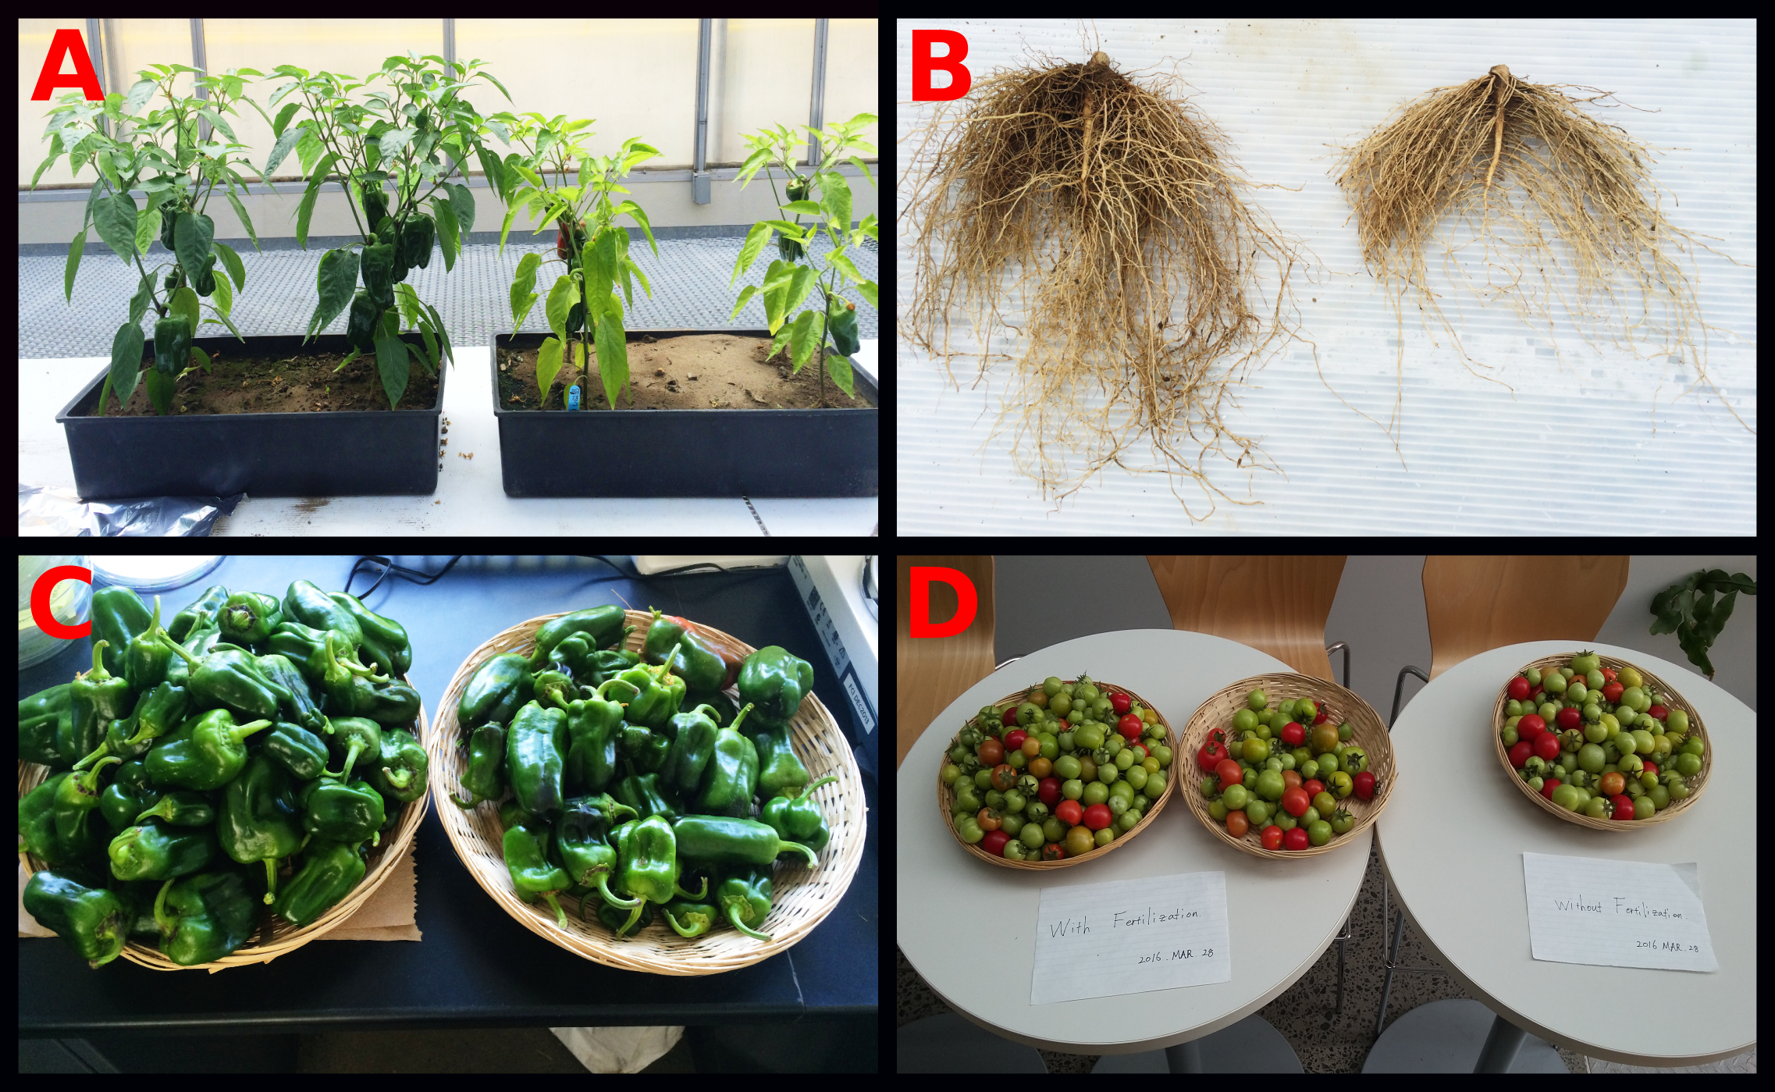  
**Figure S1: Plant productivity. Photos were taken at the end of the experimental treatment. In each photo, fertilized plants are on the left. A: pepper shoots, B: pepper roots, C: pepper fruits and D: tomato fruits.**  
 

   
Figure S2  
**Figure S2: Neighbor-Joining trees of candidates ASVs (fungi) positively associated with productivity measures. The most accurate taxonomy assigned according to the RDP bayesian classifier (form Phylum to species) was added as tip labels.**

Figure S3  
**Figure S3: Neighbor-Joining trees of candidates ASVs (bacteria) positively associated with productivity measures. The most accurate taxonomy assigned according to the RDP bayesian classifier (form Phylum to species) was added as tip labels.**  